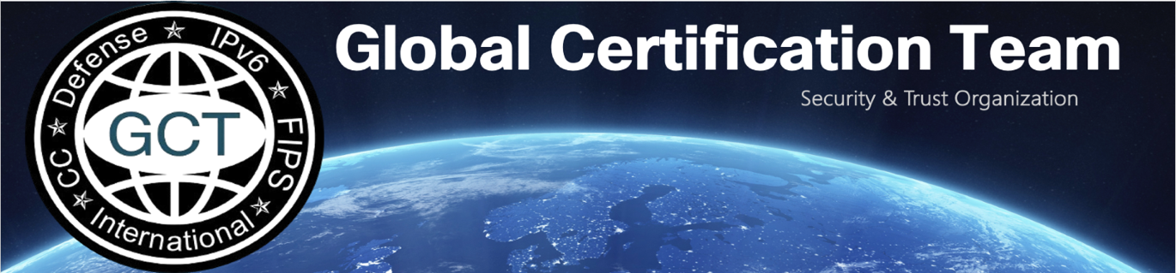
25 February 2026
Internal Compliance Review (ICR) Summary Memorandum

SUBJECT: Cisco Global Certification Team (GCT) Defense Programs (DP) Internal
Compliance Review (ICR) approval of the Cisco Session Border Controller (SBC)

Reference:
(a) Defense of Defense Instruction (DoDI) 8100.04, “Department of Defense (DoD)
Unified Capabilities (UC),” 09 December 2010
(b) Office of the DoD Chief Information Officer (CIO), “DoD Unified Capabilities
Requirements 2013 (UCR 2013) Change 2,” September 2017

- The Cisco GCT DP team has completed approval for the Cisco SBC with Software Rel. Internetwork Operating System (IOS) XE 17.18. This solution has passed CS scans and undergone Functionality Attestation (FA) conducted by the Cisco GCT DP Team. This review is effective as of the memorandum date.

- The Functionality Attestation letter containing the detailed components and configuration may be requested by email: gct-dp-icr@cisco.com

On 01 February 2026, this initial request was approved to update the Software Rel. to 17.18 for product component Interworking Border Controller (IWBC), Interworking Gateway (IWG), and Session Border Controller (SBC). The request includes ASR 1006-X, Cisco Catalyst 8300 Series, Cisco Catalyst 8200 Series, ISR 4461/K9 and Cisco Catalyst 8000v Series.

- This product/solution must be implemented only in the configuration that was tested. Please utilize this solution's deployment guide and product-specific Security Technical Implementation Guidelines (STIGs).

The Cybersecurity Summary Report (CSR) is included in the Cybersecurity Summary Report Package (CSRP) and may be requested by email: gct-dp-icr@cisco.com

Robbie Horgan
Leader, GCT DP

